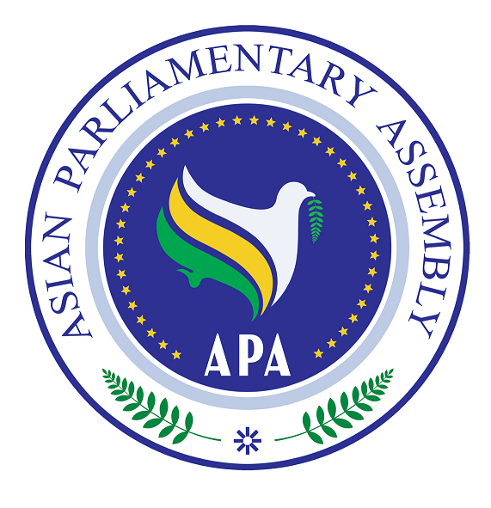

APA/Res/2010/01
30 November, 2010

Resolution on Combating Corruption in Asia

We, the Members of the Asian Parliamentary Assembly,

Recalling APA Resolutions contained in APA/Res/2007/05, APA/Res/2008/18 and APA/Res/2009/03,

Recalling also the APA Plan of Action on Combating Corruption contained in APA/Res/2007/05/Annex, and calling for its full implementation,

Urging more momentum for speedy implementation of the APA Resolutions on Combating Corruption and the APA Plan of Action,

Convinced that designation by Member Parliaments of focal points for APA anti-corruption programs and activities as well as greater exchange of information among Member Parliaments facilitate making sustained progress in anti corruption strategies by APA,

Reiterating the need for coordination, exchange of information and best practices within APA Member Parliaments under the framework of the APA Plan of Action on Combating Corruption,

Alarmed that corruption continues to have negative impacts on public and corporate governance, undermining the rule of law and security across the globe,

Recognizing the significance of the implementation of the United Nations Convention Against Corruption in the fight against corruption and, in this context, encouraging the ratification of the said Convention by all Member Parliaments,

Recognizing further that all four categories of prevention, criminalization, international cooperation and asset recovery, as stipulated in the United Nations Convention Against Corruption, are important elements in combating corruption,

Supporting the promotion of 9 December as the International Anti-Corruption Day,

Considering the need to study the usefulness of developing an Asian Anti-Corruption Convention rendering the UN Convention more specifics to Asia,

Recognizing the central role the parliamentarians can play in combating corruption,

Determined to promote the involvement and enabling of the members of the civil society, as an effective partner of the parliaments, in the fight against corruption,

Underlining the significance of strengthening the political will from all branches of governments in combating corruption,

- Welcome the Report of the Secretary-General on Combating Corruption contained in SG/Rep/2010/01 of 6 March 2010,

- Resolve, once more, to do our outmost to strengthen our anti-corruption strategies and take extra measures to promote honesty and combat corruption in accordance with the APA Plan of Action,

- Urge Member Parliaments to designate, without further delay, the focal point to coordinate their activities and exchange information and best practices within the framework of the APA Plan of Action on Combating Corruption,

- Encourage Member Parliaments whose countries are not yet parties to the UN Convention Against Corruption to expedite, in accordance with their national laws and constitutional requirements, joining the Convention as early as possible,

- Decide to study the need and utility of developing an Asian Anti-Corruption Convention in the next meeting of the Sub-Committee on Combating Corruption in 2011,

- Encourage Member Parliaments to enhance the role and the capacity of the civil society and the mass media, in their countries, in the fight against corruption,

- Decide to establish, as a first step towards developing an institutional framework to implement the APA Plan of Action, a Network of Asian Parliamentarians Against Corruption (NAPAC), in cooperation with GOPAC, where all Asian Parliamentarians may join forces to combat corruption in Asia,

- Invite Member Parliaments to cooperate and coordinate with other regional and international organizations dealing with anti-corruption activities to collect shared experiences and best practices in their efforts to fight against corruption,

- Request the Secretary-General to continue to collect information and legislative and regulatory texts from Member Parliaments in order to promote an informed exchange of information and knowledge about effective anti-corruption policies and measures,

- Request also the Secretary-General to initiate contact with financial institutions, and inter-parliamentary and non-governmental organizations active in the field of combating corruption with the aim of exchanging support and assistance as well as information and best practices,

- Request further the Secretary-General to report to the next meeting of the Sub-Committee on Combating Corruption in 2011 on the implementation of this resolution,

